Inverse & Wiener Filtering

INVERSE FILTER:

Objective: Inverse filter restores a blurred image perfectly from an output of a noiseless linear system. However, in the presence of additive white noise, it does not work well. In this project, how the ratio of spectrum N/H affects on the image restoration is demonstrated.

Given:
Suppose we have the following system in the frequency domain
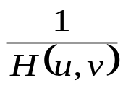
H(u,v)
G(u,v)
N(u,v)
F(u,v)
Degraded image
G(u,v)
Restored image

Note: F, G, N, H are in 2D-DFT domain.

- G(u,v)=F(u,v)H(u,v)+N(u,v)
where F(u,v) is the 2D-FT of an input image u(m,n), N(u,v) is a white noise with zero mean and unit variance, and H(u,v) is a degradation function which is given by
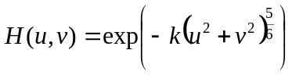

- 2D-IFT of G(u,v) is the blurred image (item 2 above) and is the output of inverse filter
- is the inverse filter. When 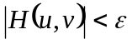, 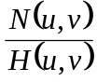 becomes very large (see Fig. 8.10c, page 277). Hence use the pseudo inverse filter defined in eq.8.26/p.276.

WIENER FILTER:

h(m,n)
g(m,n)
Restored Image
Original Image u(m,n)

Additive noise

For Wiener Filter: 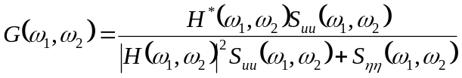

where 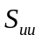and 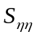 are Fourier transforms of the auto-correlation functions of u(m,n) and 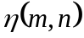 respectively.

Procedure:
- Read an image (any size up to 512x512).
- Calculate the three different H(u,v) with k=0.0025, 0.001 and 0.00025.
- Calculate G(u,v) with H(u,v) obtained in 2), and show the three different blurred images.
- Take the inverse filtering and Wiener filtering for each G(u,v).
- Show the restored images with ratios N/H, where N and H are power spectra of additive noise 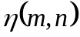and h(m, n) respectively.

Note: N, H are in 2D-DFT domain.
References:
1) Textbook Section 8.3, pp 275-284
2) Digital Image Processing by ‘Gonzalez and Woods’ pp.258-264, II Edition and pp.351-357, III Edition

NOTES:
Inverse filtering is the process of recovering the input of a system from its output. Inverse filter is obtained by dividing the degraded image with the original image in the 2D- transform domain. If the degradation has zero or very low values, then N(u,v)/H(u,v) dominates.
The inverse and pseudo-inverse filters remain sensitive to noise. Wiener filter can overcome this limitation. Wiener filtering is a method of restoring images in the presence of blur as well as noise.

